**HIVE QUERIES**

List the latest Movie Trailers

**QUERY:**

SELECT m.MovieName Video, v.URL URL,m.ReleaseDate ReleaseDate

FROM imdb.videos v

JOIN imdb.video_type vt

ON vt.videotypeID = v.videotypeID

JOIN imdb.Movie m

ON v.EntityID = m.MovieID

ORDER BY ReleaseDate DESC;

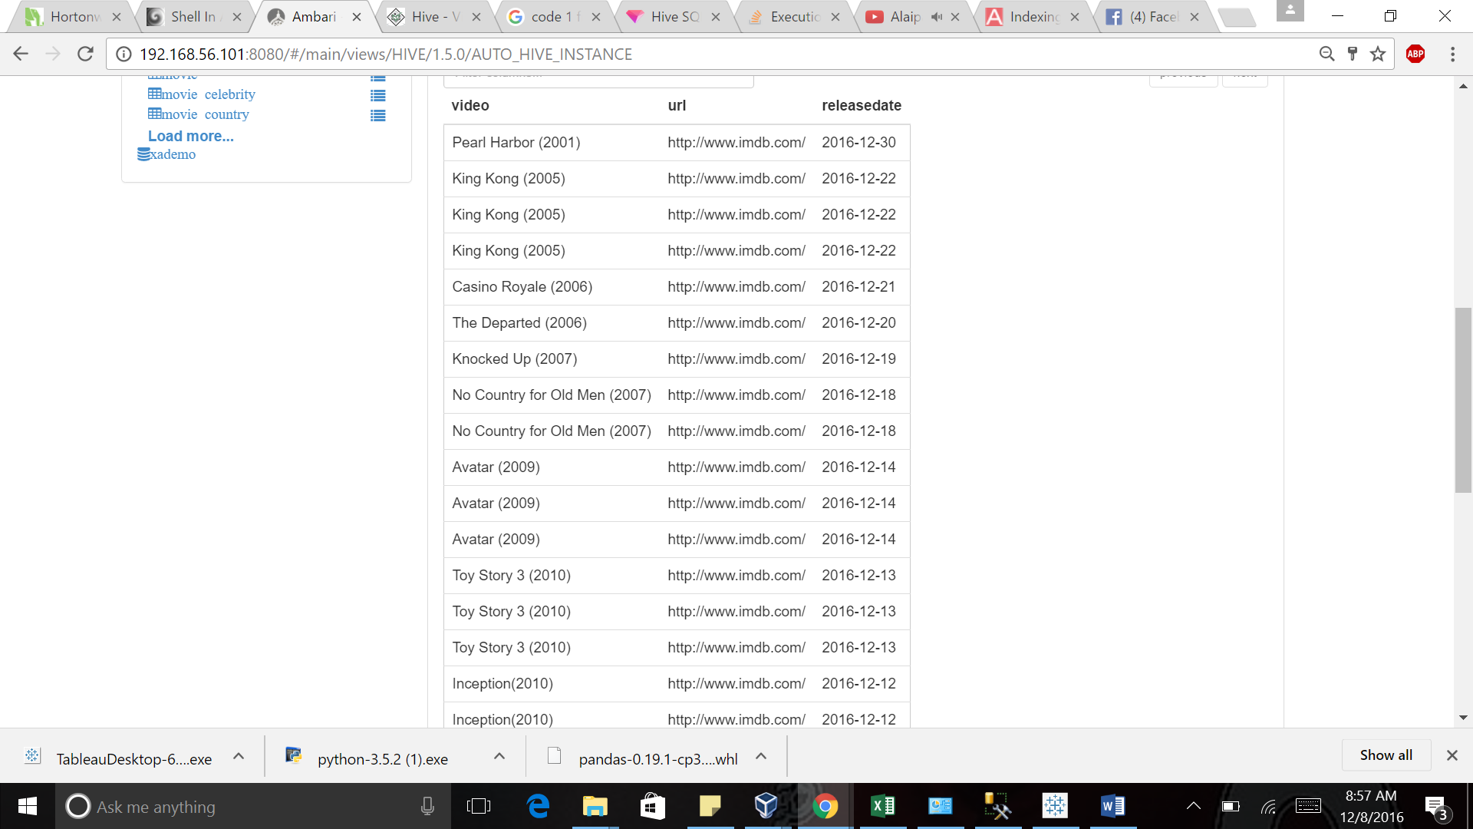

List the award name, award category awarded year and Winners

**QUERY**

SELECT ac2.CategoryName CategoryName, w.Year Year,

CASE

WHEN w.EntityTypeID = 1 THEN m.MovieName

ELSE c.CelebrityName

END Winner, ac.awardname AwardName

FROM imdb.Winners w

JOIN imdb.Awards_Cnfg ac

ON ac.AwardID = w.AwardID

JOIN imdb.Award_Category ac2

ON ac2.CategoryID = w.CategoryID

LEFT JOIN imdb.Movie m ON

m.MovieID = w.EntityID

LEFT JOIN imdb.Celebrity c

ON c.CelebrityID =w.EntityID

order by Year;

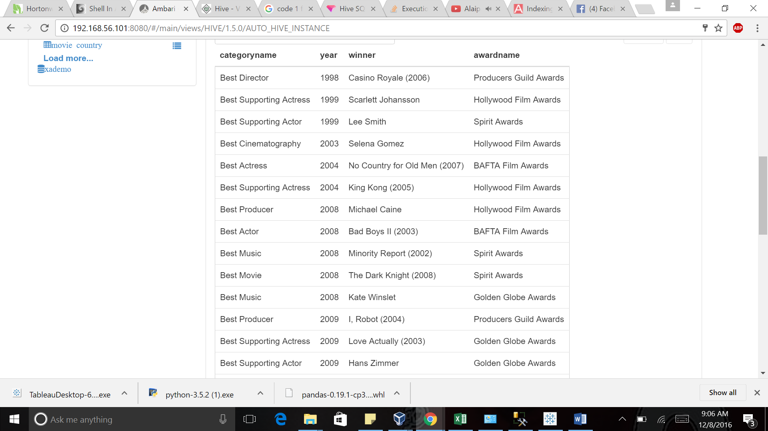

LIST THE MOVIES THAT ARE CURRENTLY SHOWING IN THEATRES

**QUERY**

SELECT theatre.TheatreID,theatre.Name TheaterName,

CONCAT(fr.AddressLine,',',fr.City,',',fs.Name,',',fc.Name,',',fr.PostalCode) AS TheaterAddress,

movie.MovieName,movie.RunTime,movie.MetacriticReview,

mr.MovieRatingName,ts.Timeslot,theatre.TheatreID

FROM imdb.Theatre theatre

JOIN imdb.Theatre_Movie_Showtime tms

ON theatre.TheatreID=tms.TheatreID

JOIN imdb.Movie movie

ON movie.MovieID=tms.MovieID

JOIN imdb.Showtimes ts

ON ts.ShowtimesID=tms.ShowtimesID

JOIN imdb.Movie_Rating mr

ON mr.MovieRatingID=movie.MovieRatingID

JOIN imdb.Address fr

ON fr.AddressID=theatre.AddressID

JOIN imdb.State_Cnfg fs

ON fs.StateID=fr.StateID

JOIN imdb.Country_Cnfg fc

ON fc.CountryID=fr.CountryID

ORDER BY theatre.TheatreID;

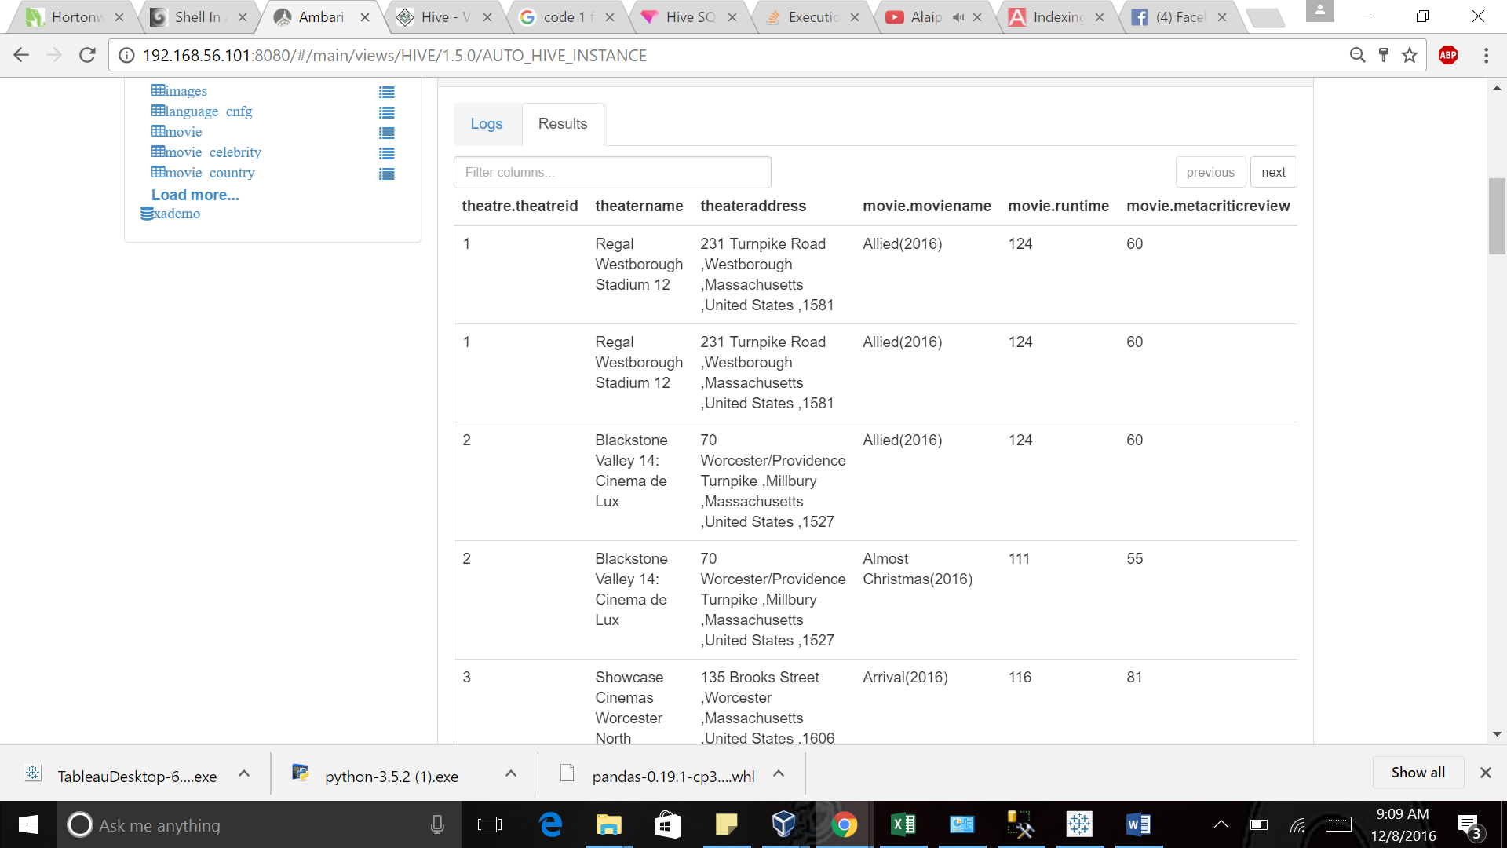

List top rated movie based on IMDB rating

**QUERY**

SELECT m.MovieName MovieName, av.URL URL, m.IMDBRating IMDBRating

FROM imdb.amazon_videos av

JOIN imdb.movie m

ON av.EntityID = m.MovieID

ORDER BY IMDBRating desc;

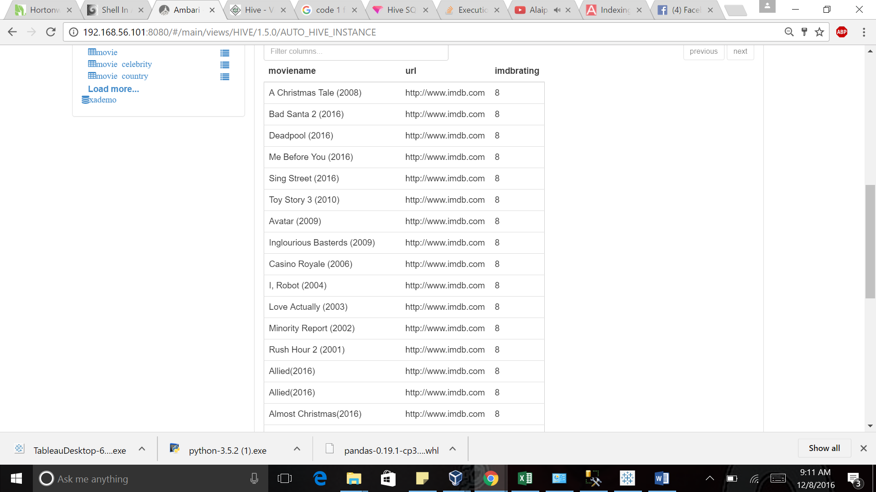

List all the soundtracks,movie or serial in which it is played along with composers and singers

**QUERY**

SELECT s.Name SoundtrackName,

CASE

WHEN s.EntityTypeID = 1 THEN m.MovieName

ELSE ts.Name

END Entity, s.Playtime PlayTime, c.CelebrityName MusicDirector, c2.CelebrityName Singer

FROM imdb.Soundtracks s

JOIN imdb.Celebrity c

ON c.CelebrityID = s.MusicDirectorID

JOIN imdb.Celebrity c2

ON c2.CelebrityID = s.SingerID

LEFT JOIN imdb.Movie m

ON s.EntityID = m.MovieID

LEFT JOIN imdb.TV_Shows ts

ON s.EntityID = ts.ShowID;

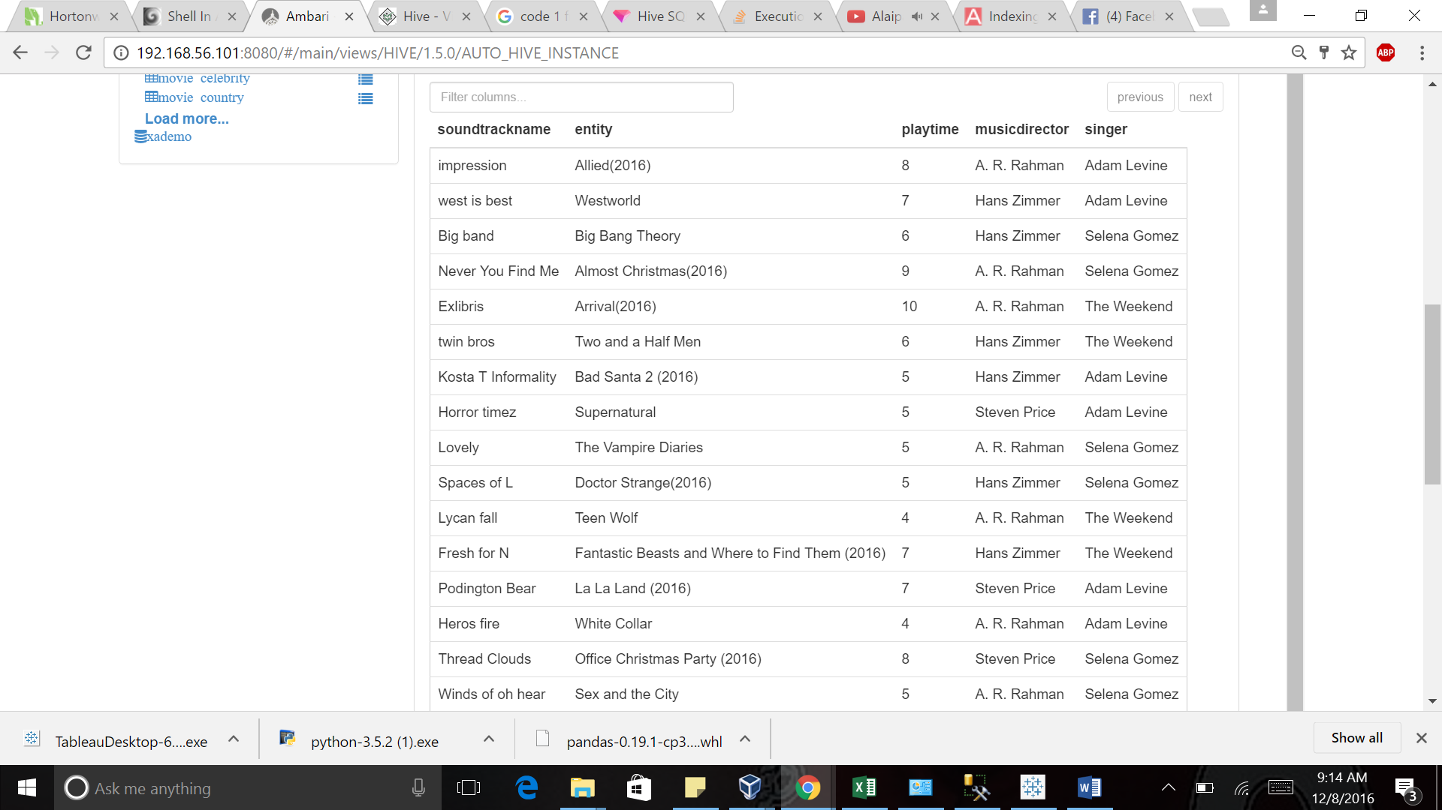

List all the TV shows along with their release date and Channel

**QUERY**

SELECT ts.ShowID SHOWID,

ts.Name AS ShowName,

c.ChannelName ChannelName,

ctsts.releasedate ReleaseDate

FROM imdb.TV_Shows ts

JOIN imdb.Channel_TV_Show_Time_Slot ctsts

ON ts.ShowID = ctsts.ShowID

JOIN imdb.Channels c

ON ctsts.ChannelID = c.ChannelID

JOIN imdb.Timeslot t

ON ctsts.TimeSlotID = t.TimeSlotID;

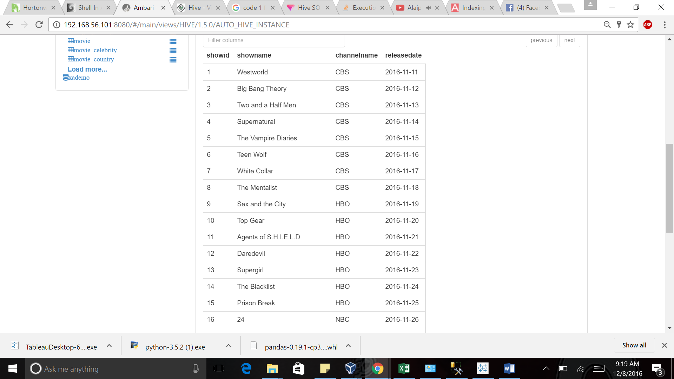

List the amazon video available for TV shows and movies

**QUERY**

SELECT

CASE

WHEN EntityTypeID = 1 THEN MovieName

ELSE ts.Name

END Entity, URL, av.views Views

FROM imdb.amazon_videos av

LEFT JOIN imdb.movie m ON av.EntityID = m.MovieID

LEFT JOIN imdb.TV_Shows ts ON av.EntityID = ts.ShowID

ORDER BY Views DESC;

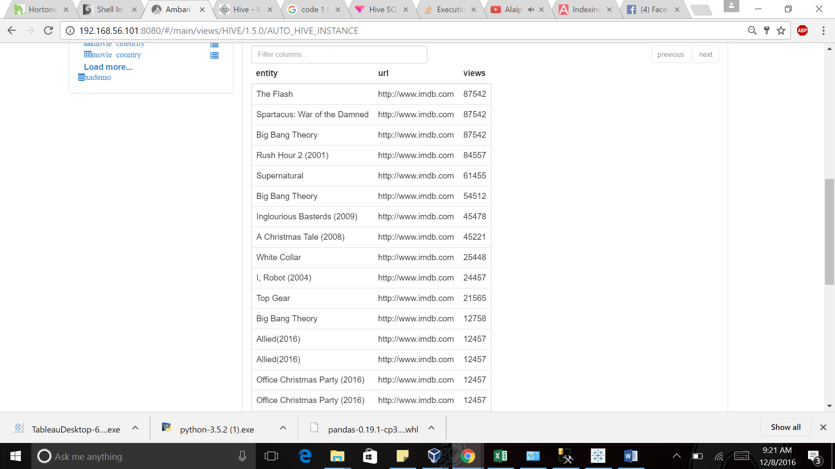

List all the DVDs available for movies

**QUERY**

SELECT

CASE

WHEN EntityTypeID = 1 THEN m.MovieName

ELSE ts.Name

END DVD

FROM imdb.Blue_Ray_DVD brd

LEFT JOIN imdb.Movie m

ON brd.EntityID = m.MovieID

LEFT JOIN imdb.TV_Shows ts

ON brd.EntityID = ts.ShowID;

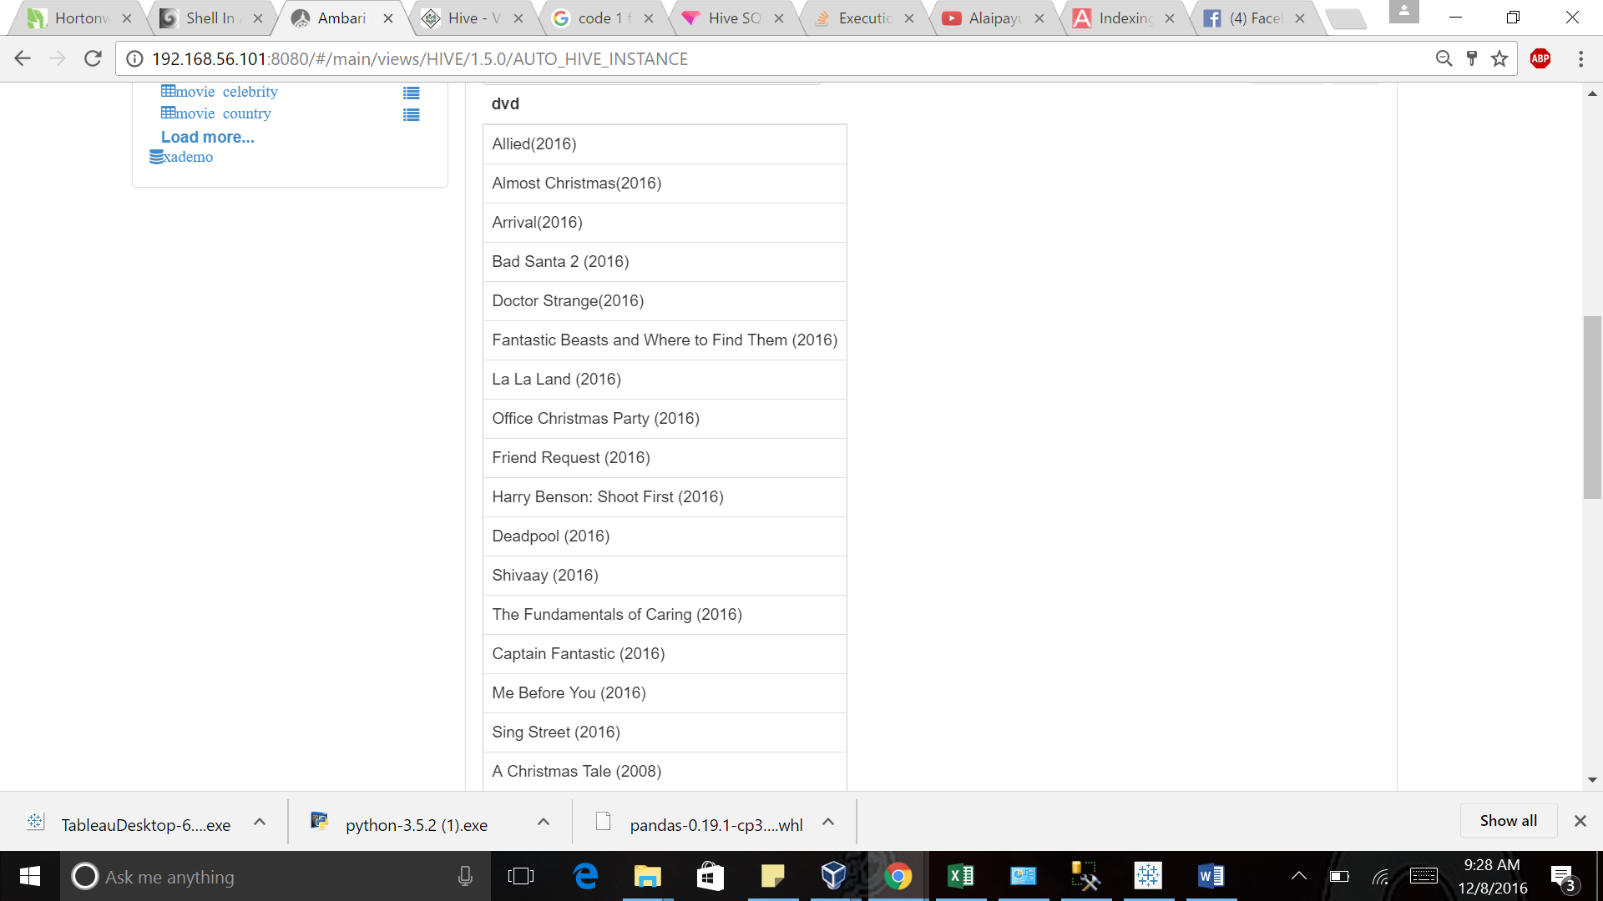

**VIEWS**

List the recently views entities

CREATE VIEW RECENTLY_VIEWED AS

SELECT

CASE

WHEN rv.EntityTypeID = 1 THEN m.MovieName

WHEN rv.EntityTypeID = 2 THEN c.CelebrityName

ELSE ts.Name

END RecentlyViewed

FROM imdb.Recently_Viewed rv

LEFT JOIN imdb.Movie m

ON rv.EntityID = m.MovieID

LEFT JOIN imdb.Celebrity c

ON rv.EntityID = c.CelebrityID

LEFT JOIN imdb.TV_Shows ts

ON rv.EntityID = ts.ShowID;

select * from RECENTLY_VIEWED;

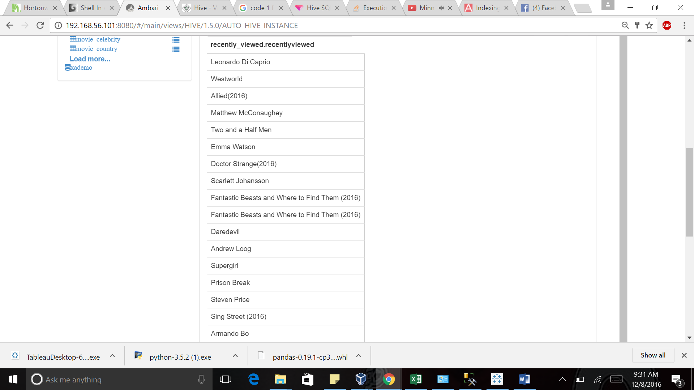

List all the news with headlines and the related entity

CREATE VIEW NEWS AS

SELECT rv.Headlines HeadLines,

CASE

WHEN rv.EntityTypeID = 1 THEN m.MovieName

WHEN rv.EntityTypeID = 2 THEN c.CelebrityName

ELSE ts.Name

END Entity

FROM imdb.News rv

LEFT JOIN imdb.Movie m

ON rv.EntityID = m.MovieID

LEFT JOIN imdb.Celebrity c

ON rv.EntityID = c.CelebrityID

LEFT JOIN imdb.TV_Shows ts

ON rv.EntityID = ts.ShowID;

select * from news;

